Pointing the Way
input file: point.in output file: point.out
A compass is usually thought of as having 4 primary points at North, East, South, and West. These directions correspond to points on a circle, with North at 0 degrees, East at 90 degrees, South at 180 degrees, and West at 270 degrees. There can be many points between the primary points. For example, the point North-East is halfway between North and East, at 45 degrees and East-North-East is halfway between East and North-East at 67.5 degrees.
This plan has been determined to be too restrictive for space travel, so you have been asked to create a more general compass, with anywhere from 3 to 26 primary points.
For example, if a compass were to have 5 points, for simplicity sake, name them with the first five letters of the alphabet as below:
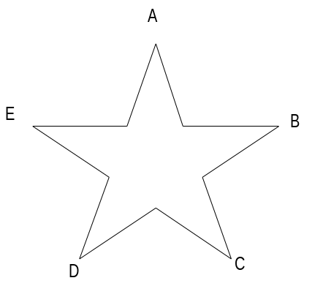
The point A is oriented with 0 degrees. This means B is at 72 degrees, C is at 144 degrees, D is at 216 degrees, and E is at 288 degrees. At 36 degrees, halfway between A and B, is the compass point AB. At 18 degrees, halfway between A and AB is the compass point AAB. At 54 degrees, halfway between AB and B is the point BAB.

To name compass points, follow the example in the chart below for a compass with 4 points and the rules below:
- 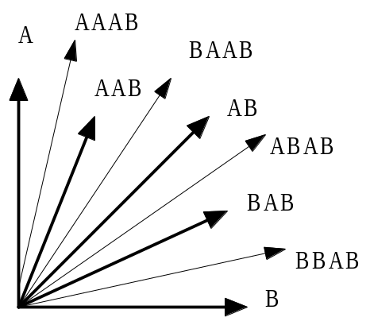The major compass points are called 1-points. The name of a 1-point is a single alphabetic character, where the first 1-point is 'A' (at 0 degrees) and others are B, C, ... in clockwise order.
- 2-points are halfway between two one points. The name of the 2-point between two contiguous 1-points, P and Q (specified in clockwise order,) is PQ.
- A k-point (where k ≥ 3) dissects an angle determined by a (k-1)-point and an n-point (where n < k-1). For instance, ABAB is a 4-point which dissects the angle of the 3-point BAB and the 2-point AB. The name of a k-point between a and β is aβ, where a is the name of a 1-point, and β is the name of the nearest (k-1)-point.
Your program must take a number of compass points and a group of compass points for each and return the degree measure of the compass point. For example, for the example above, a 5 pointed compass would place AAB at 54 degrees and CD at 180 degrees.

Input
The input will have information about a number of different input sets. The first line of each set will be a number of compass points, n, where 3 ≤ n ≤ 26. The second line of the data set will have a number of compass points to be analyzed, k. The next k lines will each have compass point, where each point is a list of between 1 and 8 upper case letters. You may assume each string represents a valid compass point for the given compass. There will be no leading or trailing blanks on a line.
The end of input will be indicated by a compass with 0 points. This data should not be processed.

Output
Output the number of points of the compass at the beginning of the output for each set. For each of the k compass points, echo the compass point and give the degree measurement it represents to 2 decimal places of precision.
Have a blank line after each data set.

Sample Input
5
3
B
BBC
AAEA
26
1
W
4
1
BBAB
0

Sample Output

Compass with 5 points:
B : 72.00 degrees
BBC : 90.00 degrees
AAEA : 351.00 degrees

Compass with 26 points:
W : 304.62 degrees

Compass with 4 points:
BBAB : 78.75 degrees

